**Games Physics: CA5 – Assignment 2**

**DECLARATION (Team member 1):**

I declare that:

* The work submitted for this assessment is entirely my own, and no part of it has been copied from any other person’s words or ideas.
* No part of this alternative assessment has been written or completed for me, it has not been discussed or collaborated on by me with any other person
* I understand that I am bound by the DkIT Academic Integrity Policy. I understand that I may be penalised if I have violated the policy in any way;

Type Your Full name: **Vilandas Morrissey (D00218436)**

..........................................................................................................................

Date: **09/12/2020**

……………………………………………………………………………………………….

**DECLARATION (Team member 2):**

I declare that:

* The work submitted for this assessment is entirely my own, and no part of it has been copied from any other person’s words or ideas.
* No part of this alternative assessment has been written or completed for me, it has not been discussed or collaborated on by me with any other person
* I understand that I am bound by the DkIT Academic Integrity Policy. I understand that I may be penalised if I have violated the policy in any way;

Type Your Full name: **Paudric Smith**

..........................................................................................................................

Date: **09/12/2020**

……………………………………………………………………………………………….

The visual demo was made using the C# Monogame engine being develop in our 3D game engine module but using our own physics solution (Rk4).

Used a library EPPlus (5.4.2) to help with exporting into an excel sheet.

Guide:

VisualSolution.sln - The code containing the visual code along with the physics.

VisualApplication -> GDGame.exe - Launch visual demo application without code included in case the above cannot run due to missing visual studio packages.

CA5_Paudric_Smith_Vilandas_Morrissey.sln - Physics console demo

Fully working console demo without dependencies for visual demo.

Excel sheets will be exported every time a demo is run (ex1, ex2, ex3 or custom) and the box hits the floor (position Z + dimensions <= 0)

Will be exported depending on where it was run from:

Visual Application -> same folder.

Console demo -> Physics\bin\Debug\netcoreapp3.1

VisualSolution -> GDGame\bin\Debug\netcoreapp3.1

Visual app move controls:

W - zoom forwards

S - zoom backwards

A - orbit left

D - orbit right

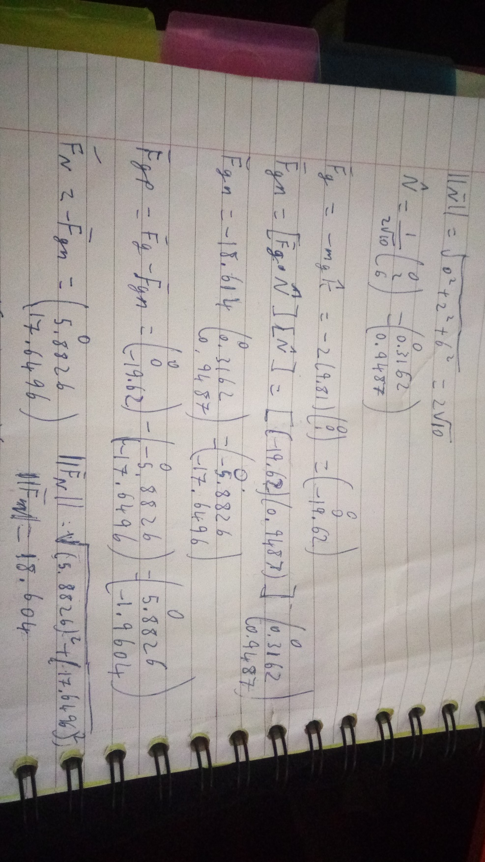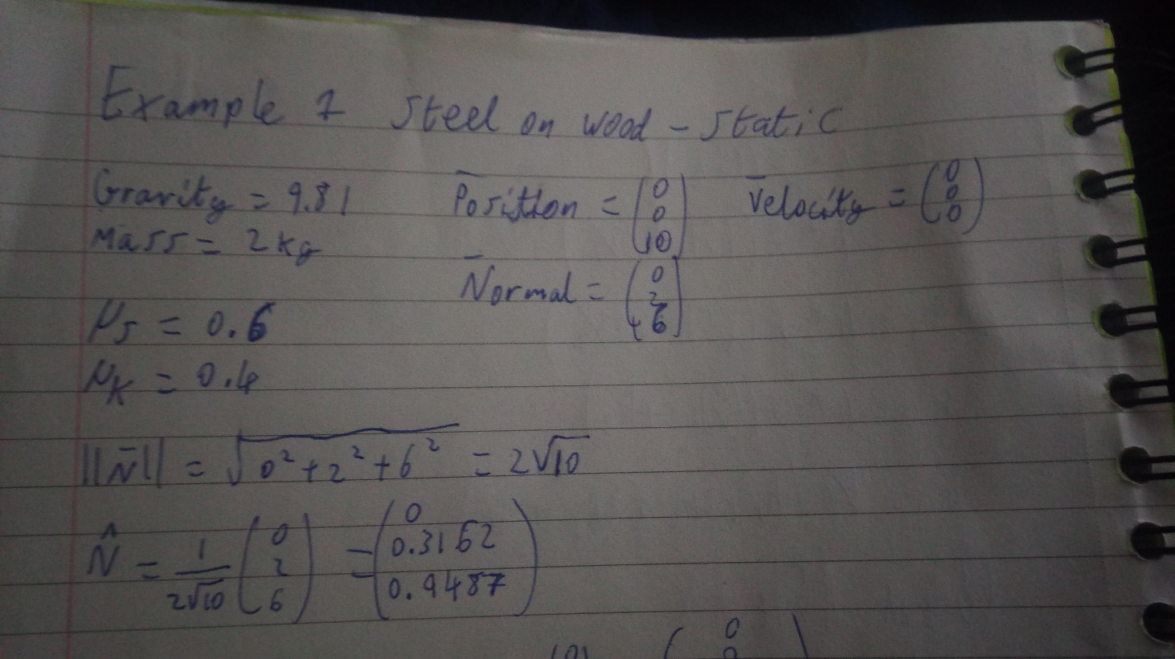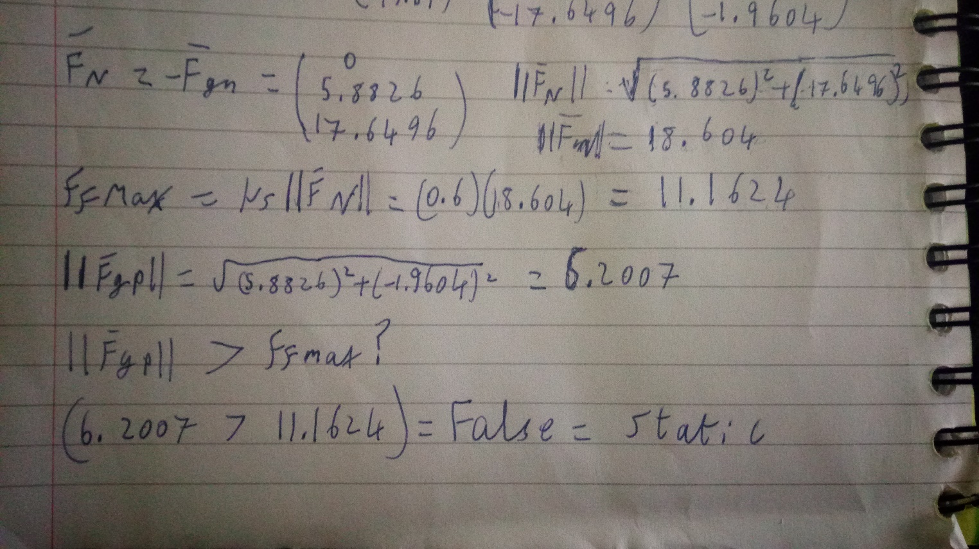Example 1: Steel block sliding on wood, demonstrating static object on a slope.

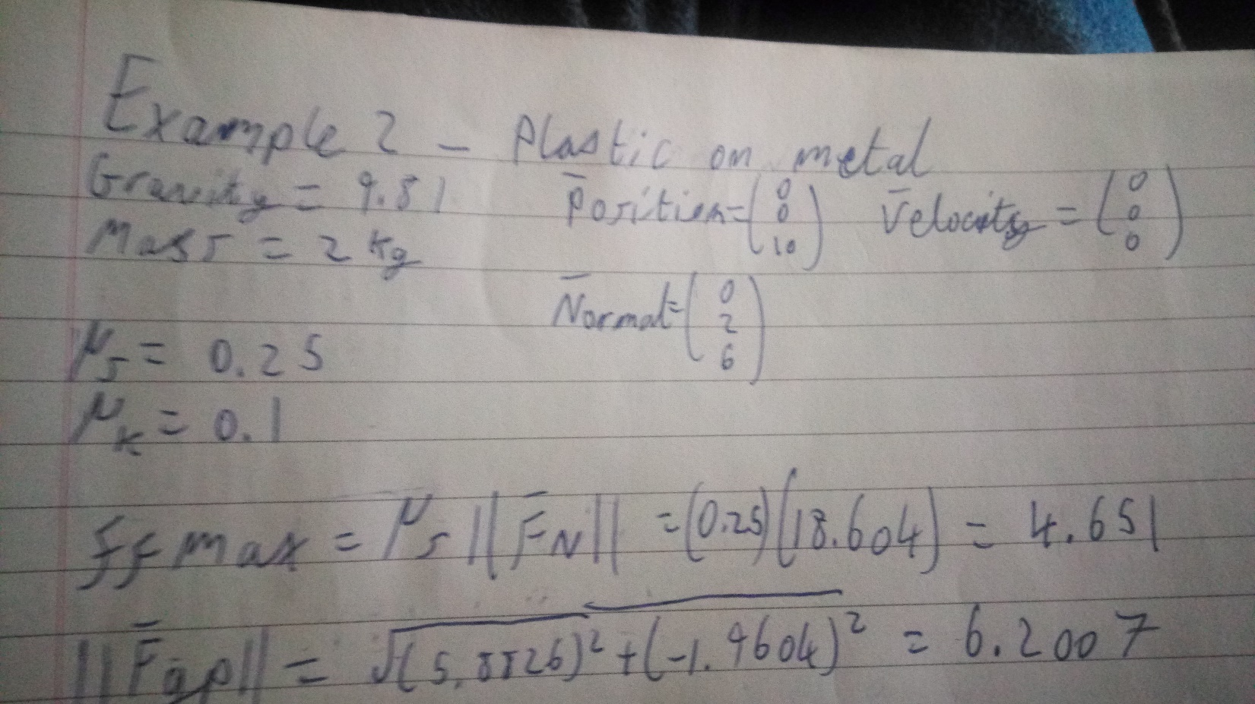Example 2: Plastic block sliding on metal, demonstrating kinetic object on a slope.

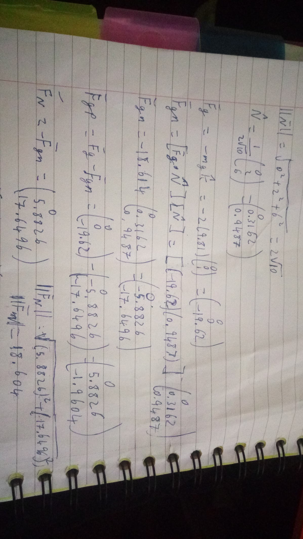

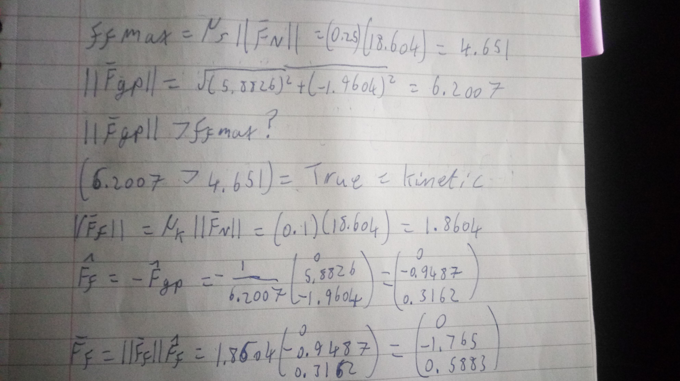

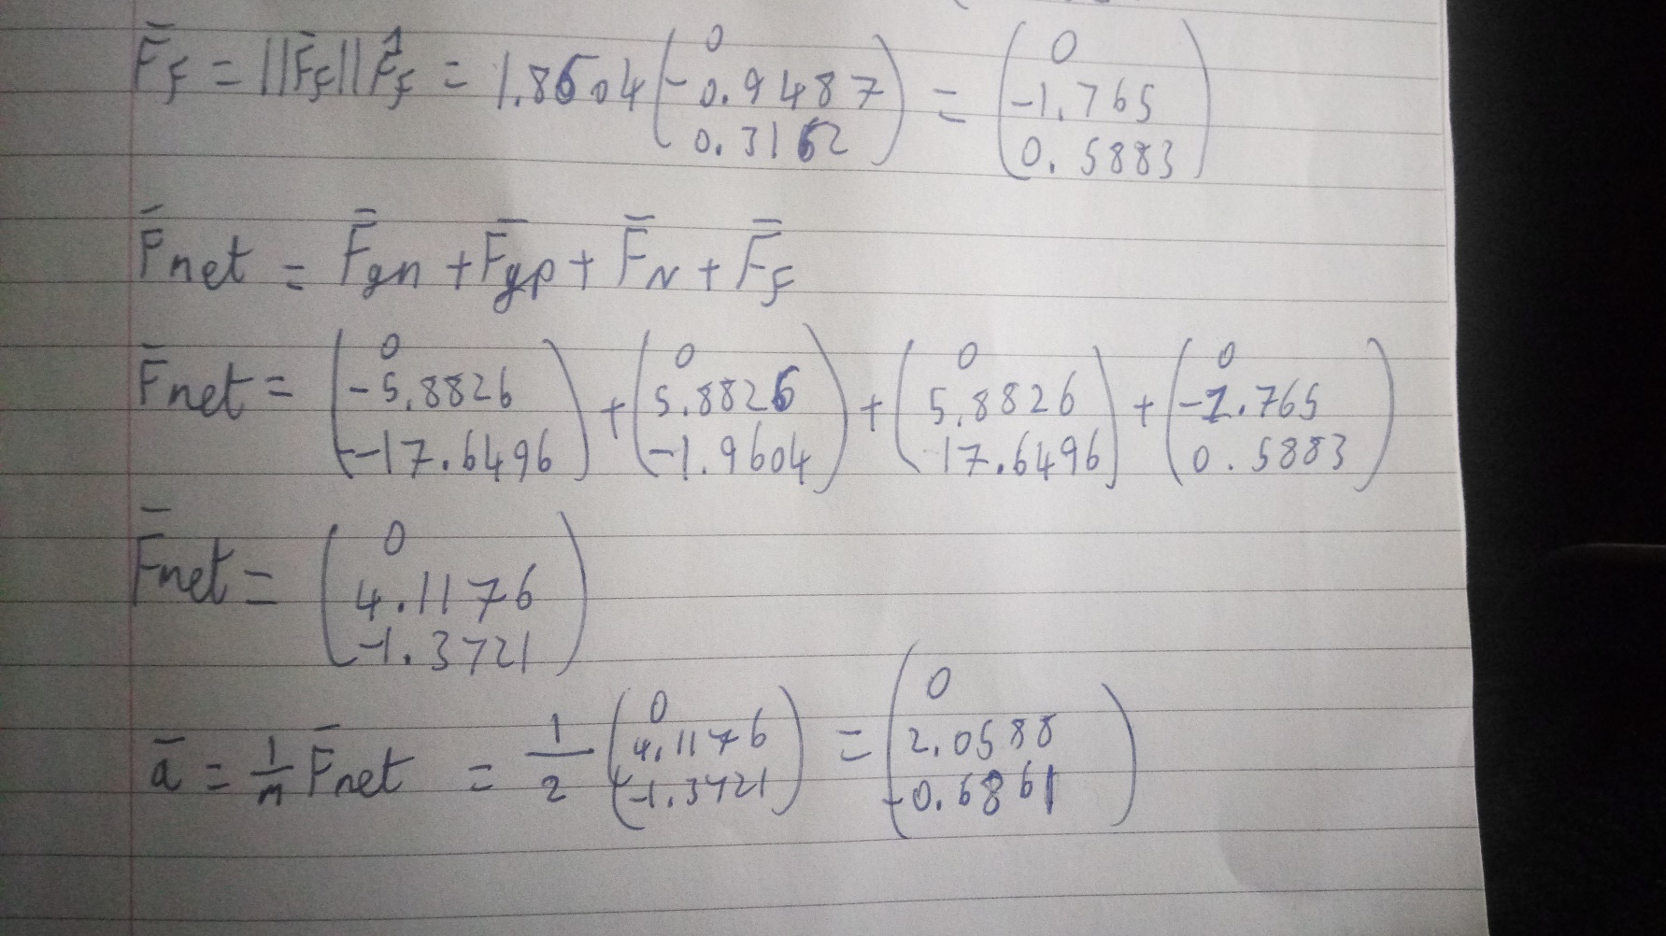

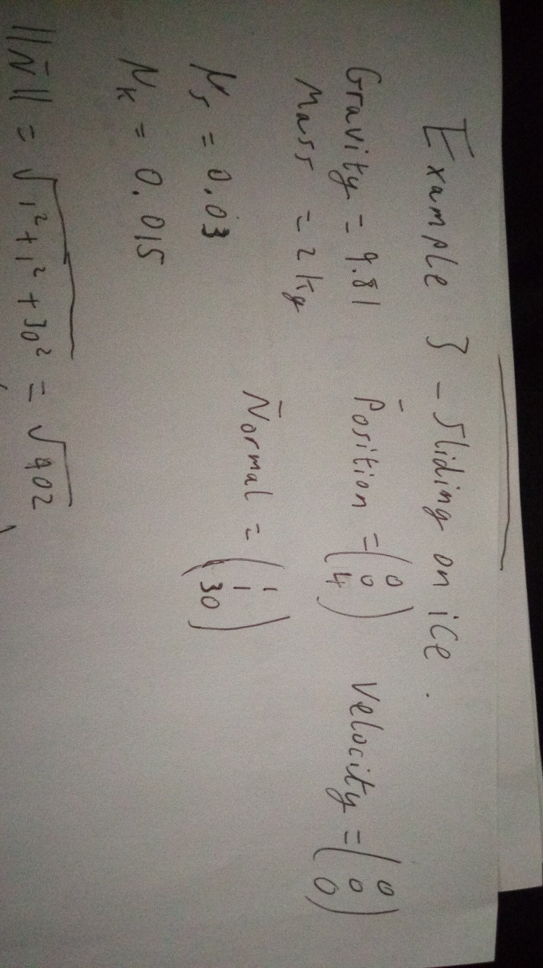Example 3: Steel sliding on ice plane with a small slope

